**Getting Started on HID over GATT**

The HID over GATT maps USB HID to the GATT (Generic Attribute Profile), so we need to start with USB HID and we will learn on how to map it.

The start point for USB HID is the USB HID Report Descriptor.

The USB HID Report Descriptor describes the Reports that a device can send and receive. Most Reports have a Report ID in from the USB Report to identify the report.

The easiest way to get started on HID over GATT is to get the USB Report Descriptor of an existing HID project. (For example you can use the nRF24LU1 project in the nRFReady Desktop). You can also use an existing USB HID Report Descriptor from the Device Class Definition for Human Interface Devices (HID) document as a start point.

A snippet of the HID Report Descriptor for the nRFReady desktop is shown below

0x05, 0x01, // Usage Page (Generic Desktop)

0x09, 0x02, // Usage (Mouse)

0xA1, 0x01, // Collection (Application)

// Report ID 1: Mouse buttons + scroll/pan

0x85, 0x01, // Report Id 1

0x09, 0x01, // Usage (Pointer)

0xA1, 0x00, // Collection (Physical)

0x95, 0x05, // Report Count (5)

0x75, 0x01, // Report Size (1)

0x05, 0x09, // Usage Page (Buttons)

0x19, 0x01, // Usage Minimum (01)

0x29, 0x05, // Usage Maximum (05)

0x15, 0x00, // Logical Minimum (0)

0x25, 0x01, // Logical Maximum (1)

0x81, 0x02, // Input (Data, Variable, Absolute)

0x95, 0x01, // Report Count (1)

0x75, 0x03, // Report Size (3)

0x81, 0x01, // Input (Constant) for padding

0x75, 0x08, // Report Size (8)

0x95, 0x01, // Report Count (1)

0x05, 0x01, // Usage Page (Generic Desktop)

0x09, 0x38, // USAGE (Wheel)

0x15, 0x81, // Logical Minimum (-127)

0x25, 0x7F, // Logical Maximum (127)

0x81, 0x06, // Input (Data, Variable, Relative)

0x05, 0x0C, // Usage Page (Consumer)

0x0A, 0x38, 0x02, // Usage (AC Pan)

0x95, 0x01, // Report Count (1)

0x81, 0x06, // Input (Data,Value,Relative,Bit Field)

0xC0, // End Collection (Physical)

0xC0, // End Collection (Application)

We now need to identify the number of Reports in this Report Descriptor. The Report ID (If the Report ID exists for a specific report) of the Reports and the size of the Reports and the type of the Reports.   
Reports can be of 3 types i.e. Input, Output and Feature.

This Report Descriptor describes 1 Report. The type of the Report is Input. The Report ID of the Report is 1. The size of the Report is 3 bytes (5bits + 3 bits + 8 bits + 8bits).

This Report sends the button state of the mouse, the Scroll wheel state of the mouse and the Horizontal pan of the mouse.

This summarizes the information that is required from the USB Report Descriptor.

|  |  |  |  |
| --- | --- | --- | --- |
| Report Number | Report ID | Report Size (Bytes) | Report Type |
| 1 | 1 | 3 | Input |

**The HID over GATT Service**

The Characteristic and Characteristic Descriptors of the HID over GATT Service

|  |  |  |  |
| --- | --- | --- | --- |
| Characteristic | | Description | |
| Report Map | | Mandatory, Contains the USB HID Report Descriptor | |
| HID Information | | Mandatory, HID version number, RemoteWake and NormallyConnectable settings | |
| HID Control Point | | Mandatory, Used by the HID Host(PC) to communicate the suspend state of the PC | |
| Report | | Optional, In our example above we have 1 Report so we have only one Report Characteristic. It is possible to have more than one Report Characteristic in a HID over GATT Service. | |
| Report Reference Characteristic Descriptor | | Every Report has a Report Reference Characteristic Descriptor which contains the Report ID and Report Type.  For the above example: Report ID is 1 and the Report Type is Input (0x01).  Input = 0x01  Output = 0x02  Feature=0x03  So the Initial value of the Report Reference should be 0x0101 and the size should be 2 bytes. |
| Protocol Mode | | Only for HID devices that are mandated to support “Boot” mode. Keyboard and Mouse are required to support “Boot” mode.  Default mode of a HID Device is “Report” mode.  Default mode is set every time a HID Device connects to a HID Host. | |
| Boot Keyboard Input Report | | Only for a Keyboard. Report for the “Boot” keyboard keys | |
| Boot Keyboard Output Report | | Only for a Keyboard. Report for the “Boot” keyboard LEDs | |
| Boot Mouse Input Report | | Only for a Mouse. Report for the “Boot” mouse buttons and movement | |

RemoteWake: The HID Device can act as a wakeup for the HID Host (Like a keyboard or mouse for a PC)

NormallyConnectable: The HID Device will advertise even when there is no activity on it. (This is used so that the HID Host can connect before human activity to reduce the perceived latency of the keyboard or mouse).

Refer to the <http://developer.bluetooth.org/gatt/services/Pages/ServiceViewer.aspx?u=org.bluetooth.service.human_interface_device.xml> for more details.

<Scroll to continue reading…>**Using the HID over GATT Service**

Use the HID over GATT Service Template which is in the nRFgo Studio.

USB Report Descriptor for the device

The USB Report Descriptor for the device should be created first or taken from an existing device. This should be valid USB HID Report Descriptor. The size of the Report Descriptor should not exceed 512 bytes for a HID Service. Multiple instances of the HID over GATT Service can be created if the device being created requires Report Descriptors that are more than 512 bytes. The USB Report Descriptor is placed in the initial value of the Report Map Characteristic of a HID over GATT Service.

Reports for the Report Descriptor

The Reports that are present within the Report Descriptor are listed; the Report ID and Report Type for each of the Reports need to be identified. A Report Characteristic is created for each Report described in the Report Descriptor, except when a Report is mapped to a GATT Characteristic that already exists in a separate GATT Service. Set the size of the Report

A Report Reference Characteristic Descriptor is added for every Report Characteristic and for GATT Characteristics that exist in a separate GATT Services. The Report Reference Characteristic has the Report ID and Report Type.

Getting started with the HID over GATT Service using nRFgo Studio

Use the HID over GATT Service provided in the nRFgo studio Service Templates to get started. Click on the “nRF8001 configuration”. Select the “nRF8001 D/DX” in the Device. Drag the “HID over GATT Service” and drop it under the “Local” tab. See the attached QuickTime video on how to do this.

Initialize the values for HID Report Map.

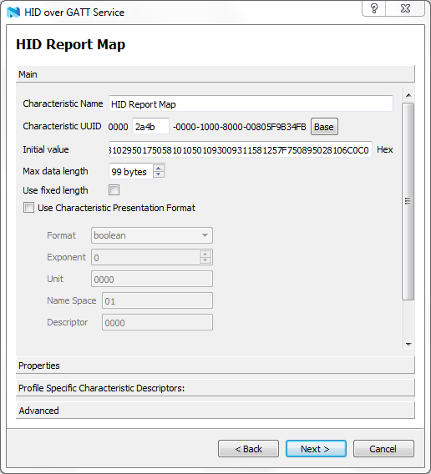Adding an new Report to a HID over GATT Service

Figure 1 Initialize the values for the HID Report Map

Add Reports to the HID over GATT Service in the nRF8001 configuration to match the number of Reports as described in the Report Descriptor.



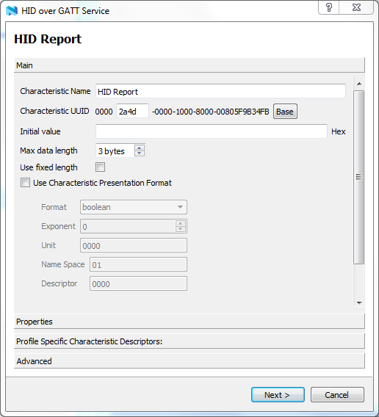

Figure 2 Set the Max data length to the size of the Report

Edit the default value in the Report Reference Characteristic to have the correct Report ID and Report Type. Select use fixed length since the size is always fixed to 2 bytes.

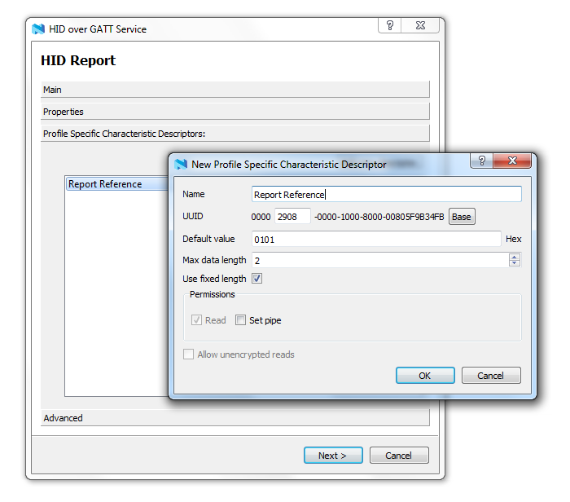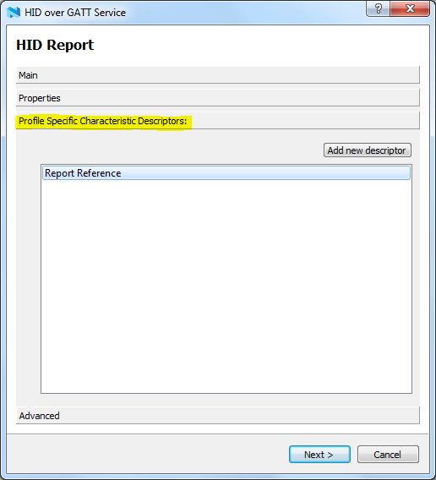Setting the GATT Appearance Characteristic

<<To be added>>